“First impressions”
Additional material

Resource. https://cutt.ly/hybZgxY

Resource. https://cutt.ly/oybZjJQ

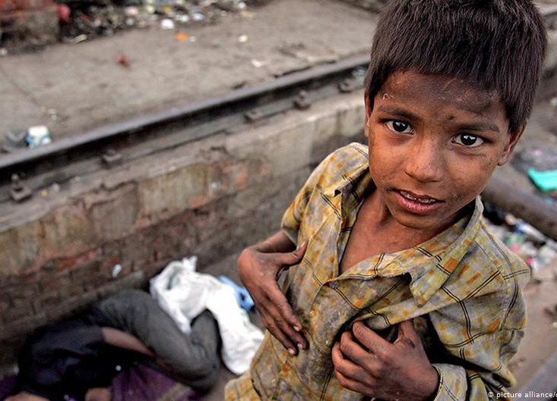

Resource. https://cutt.ly/LybZlvA

Resource. https://cutt.ly/KybZxSl

