HAVING A SUNDAY ROAST DINNER

One of the most iconic things about Britain is a Sunday roast dinner. Sunday is not a proper Sunday unless they have a roast dinner. And it’s the favourite meal of the week. Roast Chicken, Beef, Pork, Gamon or Lamb, it doesn’t matter what meat, Brits love a Sunday Roast. In fact they also like to mix it up a bit and have a couple of different types of meat, especially when they go out for a carvery. Roast potatoes and Yorkshire puddings are a must.

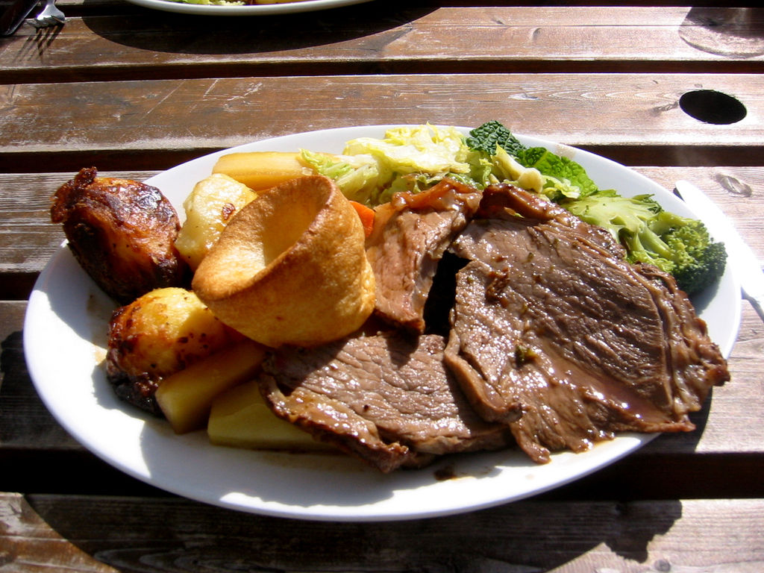

PUTTING THE KETTLE ON

Brits don’t need an excuse to put the kettle on. If there is a crisis, or they are celebrating, or someone comes to visit the first thing they do is put the kettle on. There are some Brits which are very particular in how tea should be made. Some have to add the milk last. A tea bag needs to stew in boiling water to get the full flavour, once it’s as dark in colour, only then the milk should be added. Some people get angry if tea is not made correctly.

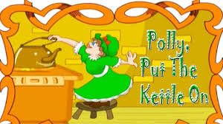

BISCUIT DUNKING

Dunking biscuits in tea is serious business in Britain. There is even a website dedicated to the practice! According to those that have taken the tea dunking survey the plain digestive is their favourite biscuit to dunk. Dunking biscuits is fine when it comes to digestives, bourbons, custard creams or the hobnob. However it’s quite a different story if you have bought lesser known biscuits and tried the dunk. There is nothing worse than losing your biscuit in a fresh cup of tea. Many people try to grab it quick and if they are lucky will be successful, but some of them tend to let it sink. The only trouble with the sinking strategy is remembering it’s there. There is nothing worse than getting a mouthful of soggy biscuit from your last slurp of tea. Many people will refuse to drink the tea and make a fresh cup if they accidently dropped the biscuit.

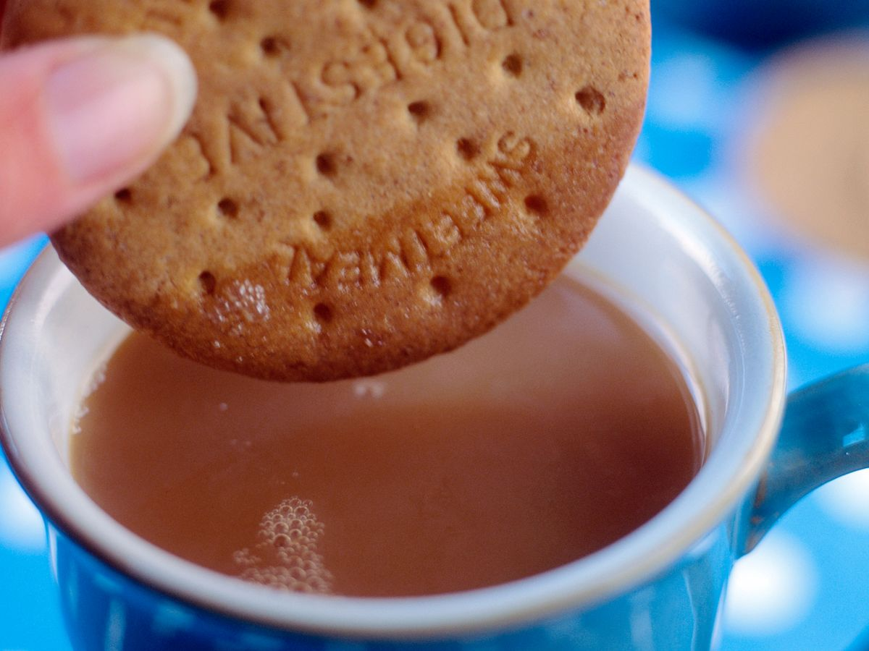

WEARING SUMMER CLOTHES THE MINUTE THE SUN COMES OUT

Stripping off at the first sign on sunshine is a very British thing to do. It doesn’t matter what time of year it is, if the suns out and it feels warm, they will strip for the occasion. If the sun is shining in winter, you can be sure to find some brave chap wandering the streets in a pair of shorts.

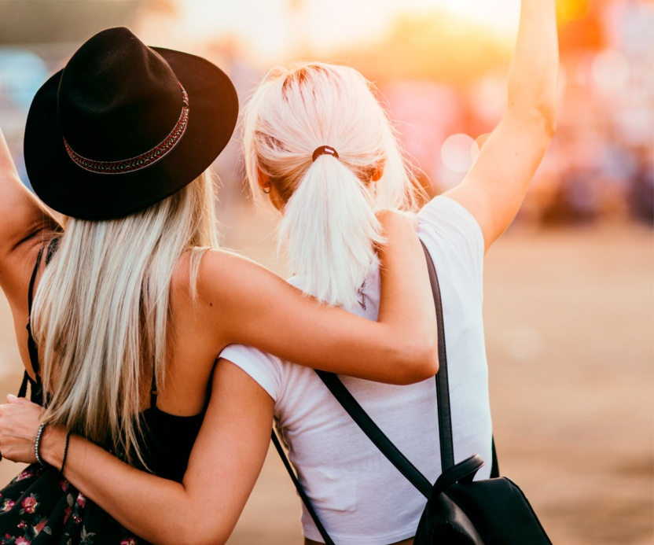

SAYING SORRY

Brits pride ourselves on being polite and using manners. However they do go overboard and apologise for everything. Even when they have done nothing wrong they still say sorry! Why do they do this? I am not sure, but I think a lot of the time when they use the word sorry they actually mean ‘excuse me’.

CHEERING ON THE UNDERDOG

Brits always love to see the underdog come out on tome. One prime example is how they all got behind Susan Boyle back in 2009. When she said she wished to be as successful as Elaine Page the judges and crowd collectively rolled their eyes and sneered. But the moment she began to sing, the crowd and the nation were behind her. It’s similar to how they all loved the first Rocky film, an average kid goes the distance with world heavyweight champion.

EATING A FULL ENGLISH BREAKFAST

Britains all love a good full fryup. From some experience of people, who having travelled quite a bit, the best place to get a full English breakfast is England. Countries abroad try their best to accommodate us, but they never get it right. You need quality sausages, proper bacon, couple of eggs, fried or scrambled, tomatoes, beans, mushrooms and a fried slice of toast. They all have our preferences but the main stay is quality sausages and bacon.

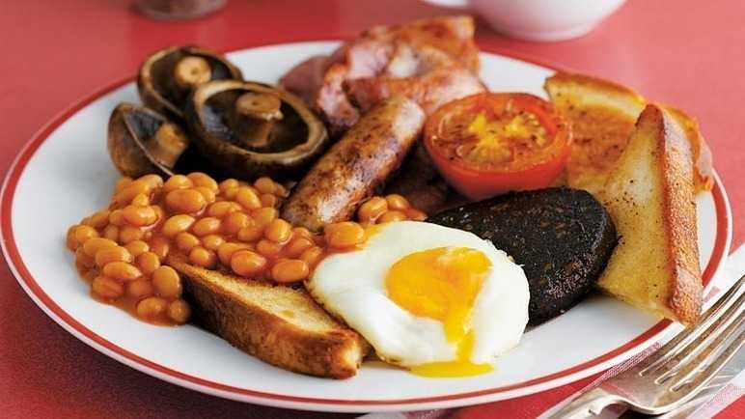

NEVER JUMPING THE QUEUE

It’s rare you will see a British person jumping the queue. Brits have the ability to queue nicely and wait our turn even if there are no barriers, signs or security enforcing them to do so. Their amazing queue etiquette was on display when hundreds of Ed Sheeran fans queued to enter the 02. There were no barriers in place but the fans formed a perfect ‘S’ queue and waited their turn to enter.

TALKING ABOUT THE WEATHER

Brits talk about the weather as often as they say sorry. WThey are obsessed with talking about it. They are a small island and their weather is very unpredictable. It is all down to our location in the world. There is a lot of moisture in the air and water in the atmosphere makes the weather unpredictable. One day it can be warm enough for summer clothes, but the next cold enough for overcoats and central heating. They have had hot weather in November and cold weather in August. Luckily they are prepared to an extent, they all know all about layering clothing in this country. What they as a country are never prepared for is weeks and weeks of the same weather, be it a heat wave or snow.

EATING TURKEY ON CHRISTMAS DAY

The majority of families in the UK will eat turkey on Christmas Day. As a country they get through on average over 10 million turkeys at Christmas time. Often families do like to have other meats, but Christmas wouldn’t be Christmas without Turkey.

