Додатки

Appendix 1. Pictures
(Додаток 1)

Picture 1

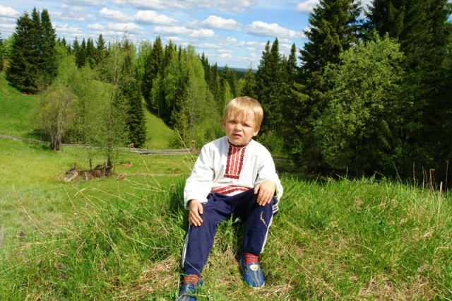
Picture 2
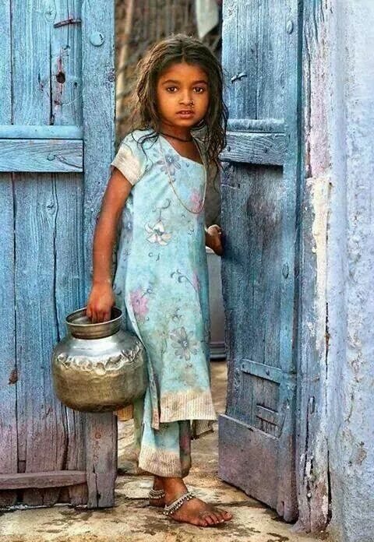

Picture 3



Picture 4
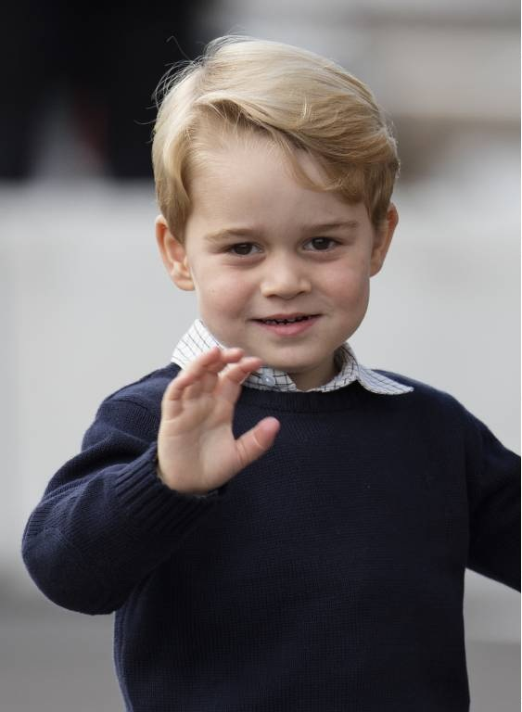

Picture 5


Appendix 2. Cards for generating groups
(Додаток 2)



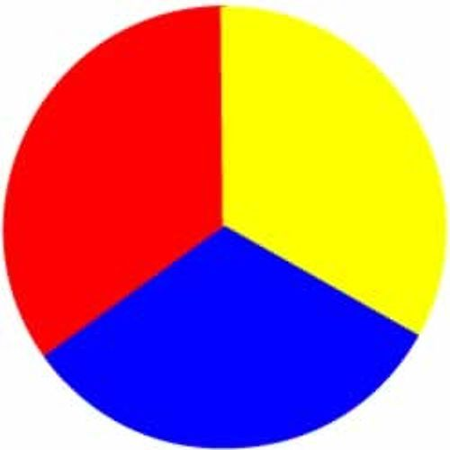



Appendix 3. The Debriefing Cube
(Додаток 3)

 |  | How do you feel now?
What do all these similarities and differences mean, in your mind? | What have you learnt? | What difficulties did you have while working? How did you choose the answers for your story? | What similarities has your life got with the life of the main hero of your story?
 |  | What are the differences between you and the main hero of your short story?

